Lightspeed Web Trader Manual v 1.2 updated 6/4/2013

Contents
WATCHLIST 3
CHARTS 4
TOP LISTS 7
ORDER ENTRY 8
OPTION CHAIN 10
OPEN ORDERS / CLOSED POSITIONS / OPEN POSITIONS 11
ACCOUNT SUMMARY / BUYING POWER 12
SYMBOL SEARCH 13
NEWS 14
PROPERTIES / SETTINGS 15
LINKING WINDOWS 16
NESTING WINDOWS 17

WATCHLIST
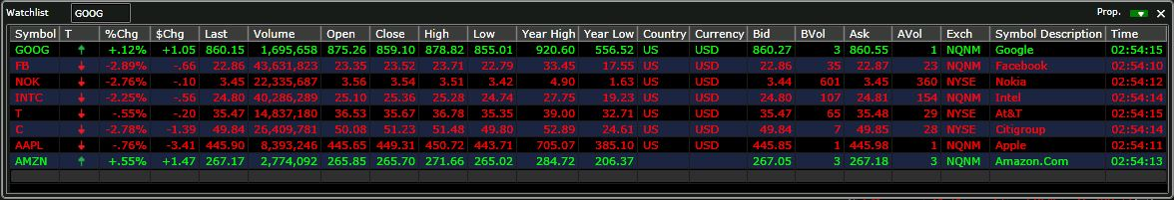
The watchlist window provides a real-time, tick-for-tick streaming view of user defined symbols. Users can set a list of up to 20 symbols to watch. Column order can be rearranged and each of the rows can be sorted by clicking on the column header. For example, clicking n the symbol column will sort all symbols alphabetically.
Symbols can be entered from the top text box, and symbols deleted just by clicking on the symbol and pressing the delete key on the key board. The Settings for the window can be launched by clicking the Prop button in the upper right hand corner.
Available columns are:
- Symbol
- Tick
- % Change
- $ Change
- Last
- Last Volume
- Volume
- Open
- High
- Bid
- Bid Volume
- Ask
- Ask Volume
- Low Close
- Year High
- Year Low
- Country
- Currency
- Exchange
- Symbol Description
- Time

CHARTS
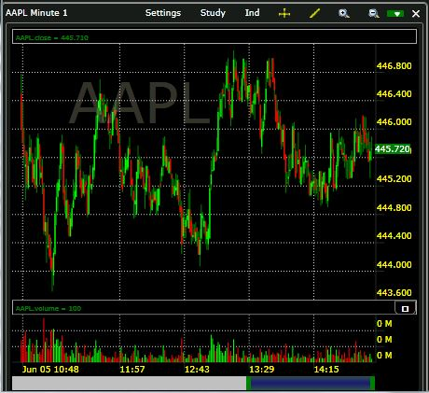
The Lightspeed Web Charting Suite provides the user with the ability to open multiple chart windows simultaneously. Users can set up either intraday or daily charts. Intraday charts can be set at any minute interval desired. Users can view a three day time span of intraday data and can go back up to 5 years of historical data.
The chart window can be linked by using the color coded drop down in the upper right hand corner, and the settings can be opened by clicking the Settings button in the title bar.
Multiple line studies can be drawn onto the charts. Line types include:
- Standard drawing line
- Vertical line
- Ellipse
- Error Channel
- Fibonacci Arcs
- Fibonacci fan
- Fibonacci retracement
- Fibonacci time zone
- Gann fan
- Quadrant line
- Raff regression
- Rectangle
- Speed lines
- Tirone levels
- Trend line
Drawing objects can be removed by doing the following:
- Select the line or object by left clicking
- Hold the mouse pointer over it until the object is highlighted
- Left click on the object and a submenu will pop up with an edit and delete option
In addition the color of each line is totally customizable as per the users preference.
The cursor crosshair can be toggled on or off by pressing the cross button on the chart toolbar. The chart can be zoomed in or out by clicking the + or – magnifying glass on the chart toolbar. Zooming and scaling can also be done by dragging the bottom green dither at the bottom of the chart to the right or left.
The web charts can have multiple indicators added as overlays onto the charts. Each indicator can be customized with respect to period and color. Multiple indicators can be added simultaneously.
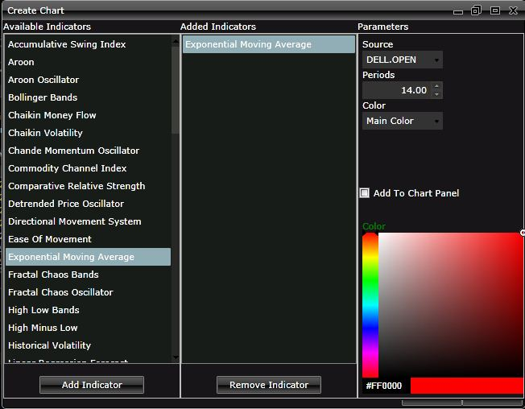

TOP LISTS
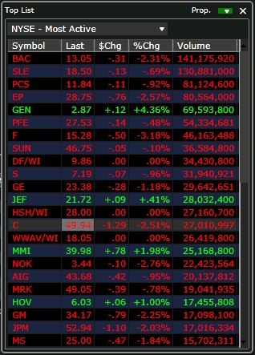 | The Lightspeed web platform includes the Top List window, which shows the top 50 symbols in each category for each exchange. The exchanges currently covered are:  - NYSE  - AMEX  - NASDAQ  - OTCBB  - Pink Sheets  The list filters for each exchange are:  - Most Active  - Percent Change Up  - Percent Change Down  - Net Change Up  - Net Change Down
The Top List window can be added to a link group by using the link group drop down in the upper right hand corner, and the properties for the window can be opened by clicking Prop. in the window’s title bar.

ORDER ENTRY
Equities
The Lightspeed Web Trader is equipped with two order entry window types: one for trading equities and one for trading options. Users can open up to three Equity order entry windows and one options order entry at the same time.
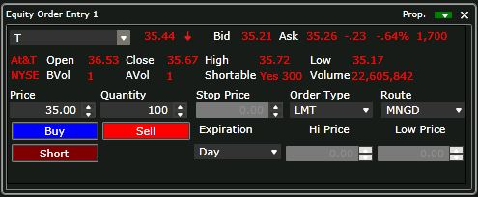
The order entry window allows the user to buy, sell or short an equity or option symbol. Price, volume, order type, route and expiration can be set from this window. Symbols can be entered into the symbol box on the top left input box, and previously entered symbols can easily be retrieved by clicking the drop down arrow. The Equity Order entry can be lined to other windows in the platform by clicking the color coded drop down in the upper right hand corner of the window, and selecting a matching color to other windows in the link group.
The platform supports: Market, Limit, Stop Market, Stop Limit and Range Orders. Range orders can be set with a high and low price, meaning, if a long position exists, placing a range order with a price below current trading price and a price above current trading price, when one of those prices are met, the position will be sold, and the opposite side cancelled. These orders are placed as a bracket. This means that if one side is cancelled, the other will also be cancelled. This is a powerful order type that can babysit a position, stopping the position out of the low price is triggered or selling for a profit of the high price is hit.
A double click on a symbol in the watchlist, top list or option chain window will load that symbol into the appropriate order entry window.

Options
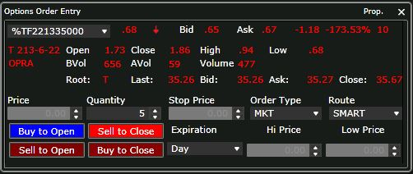
The options order entry is linked to the options chain by default. Once a symbol is double clicked on, that contract will automatically populate into the options order entry. Option positions are entered by using either the Buy to Open or Sell to Open buttons, and positions are closed using the corresponding Sell to Close or Buy to Close.

OPTION CHAIN

The option chain window shows all available months and strike prices for both calls and puts. Strike prices are displayed in groups of ten at a time. Available months and strikes within those months can be toggled just by clicking the corresponding tab at the top portion of the window. Once the underlying symbol is entered into the symbol box at the top of the window, the tab is defaulted to the current month’s at the money strikes, based on the current price of the underlying security.
The option chain window is linked by default with the options order entry, but can also be linked to other windows using the color coded link drop down in the upper right hand corner of the window. Once the chain is linked to other windows, and symbol changes will change the underlying symbol in the option chain, thus displaying the current at the money contracts.
Properties for the option chain window can be launched by clicking Prop in the upper right hand corner.

OPEN ORDERS / CLOSED POSITIONS / OPEN POSITIONS

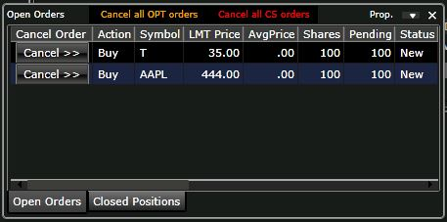
The Open Orders window shows all of the users’ open and partially filled orders. Open orders can be cancelled by clicking the cancel button of the corresponding order. Once an open order is partially or fully executed, the order will disappear from the Open Orders tab and then appear in either the Open or Closed Positions tabs of the window. Cancel all equity orders can be done by clicking the Cancel all CS orders and all open option orders can be cancelled by clicking the Cancel all OPT orders.
The Open Positions window will show all open positions that the account is holding as well as display a real-time profit or loss for each position based on the entry price.
The Closed Position window reflects all closed positions and the realized profit or loss for each closed position.
The tabs of this window can be broken out into separate windows by simply dragging and dropping the tab away from the window. Conversely, windows can be added as tabs back into the window by dragging the window on top of the window and the letting go of the mouse in the yellow center box that appears.

ACCOUNT SUMMARY / BUYING POWER
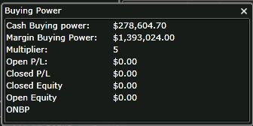
The Buying Power window displays the Cash, Margin, the buying power multipler, the open and closed profit / loss, as well as the open and closed equity and the overnight buying power. The cash and margin buying power, profit / loss and equity numbers will all update in real-time as trades are placed. The ONBP (overnight buying power) is for informational purposes only and will not update.

SYMBOL SEARCH
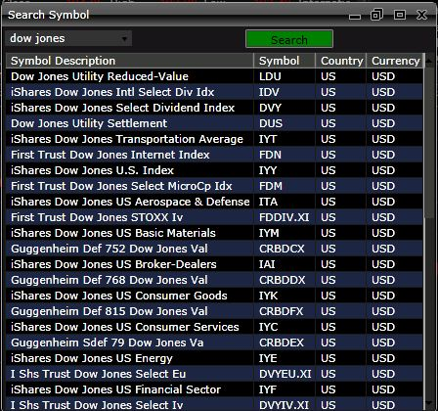
The symbol search window is a powerful way in which to search for symbols. Upon locating the symbol being searched for, a double click on the symbol will load that symbol into the order entry window.

NEWS

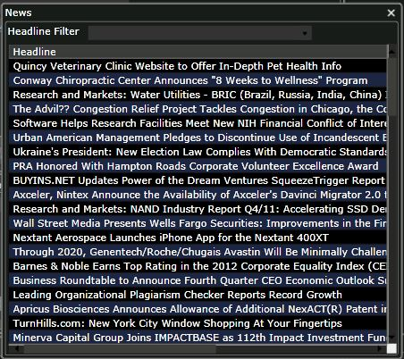

The news window streams news stories in real-time. If a filter is applied by symbol or keyword such as earnings, only those stories will appear in the window. Double clicking on any headline will bring up the entire text of the article in a new browser tab or window.

PROPERTIES / SETTINGS

From the File menu of the main program toolbar, the Properties menu item can be located. This window is the setting controller for each individual window, as well as for global settings for the entire program. Common settings include such thing as price colors, background colors, time format, text alignment and number formats.
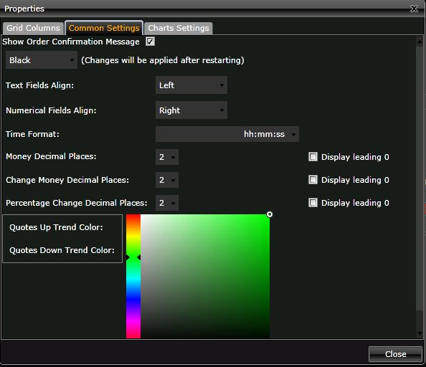
From this window, users can elect to enable Show Order Confirmation Message when placing an order by checking that box. All of the colors of the platform can be set here, as well as the number of decimal places displayed on pricing and order entry.
The Grid Columns tab provides for the ability to customize which columns are displayed in the Open Positions, Closed Positions, Order History, Open Orders, News, Watchlist, Top List, and Options Chain.
Properties and settings can also be opened directly from any individual window by clicking on Prop in the upper right hand corner of the window.
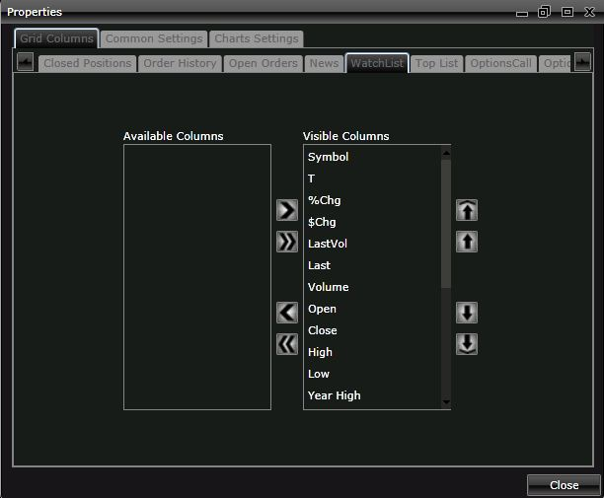

LINKING WINDOWS

Windows can be linked to each other on the platform so that when a symbol is changed in one window, the windows that it is linked to will also update with the newly changed symbol. The linking functionality is done using the color coded drop down on the title bar of each window. Users can create up to four different linked groups. All windows that are set with the same color are linked to the same link group.
In this image, the user has an order entry in the red linked group with the chart about to be added to the red B link group.
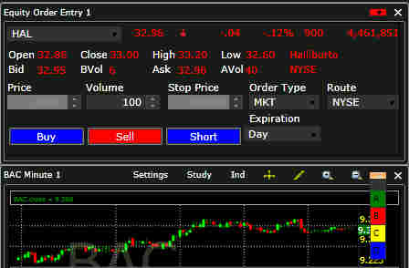

NESTING WINDOWS

One of the “coolest” features on the Lightspeed Web Trader is the ability to nest windows within each other. This is a particularly useful function to group the account management or portfolio windows together. These windows include:
- Open Orders
- Open Positions
- Closed Positions
- Order History
- Account Summary
However, any and all windows throughout the platform can be nested. It is also useful when dealing with smaller monitors or monitors with low resolution, where screen real estate becomes very important. In order to setup a nested window scenario, the first step is to right click in the top title bar of each window and click on Dockable.
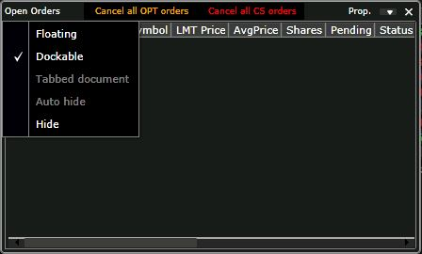
Once two windows are made dockable, click and hold the left mouse button and drag one window over the other until you see a yellow box with 4 arrows. Once that is displayed, hover the mouse over the center square, and the windows will now be nested, providing the ability to toggle the windows just by clicking in the newly created tabs along the bottom of the new merged window.
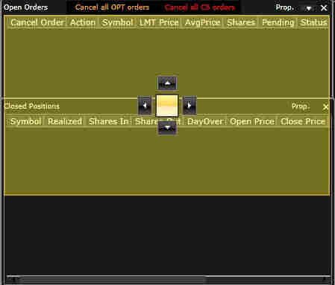 | 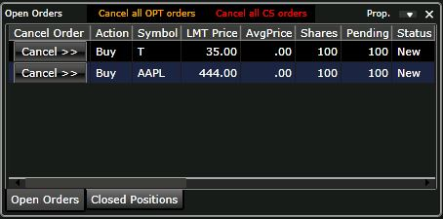
To remove a window from the nested group, just left click and hold on the tab itself and drag the window out of the group.

